**Login page**

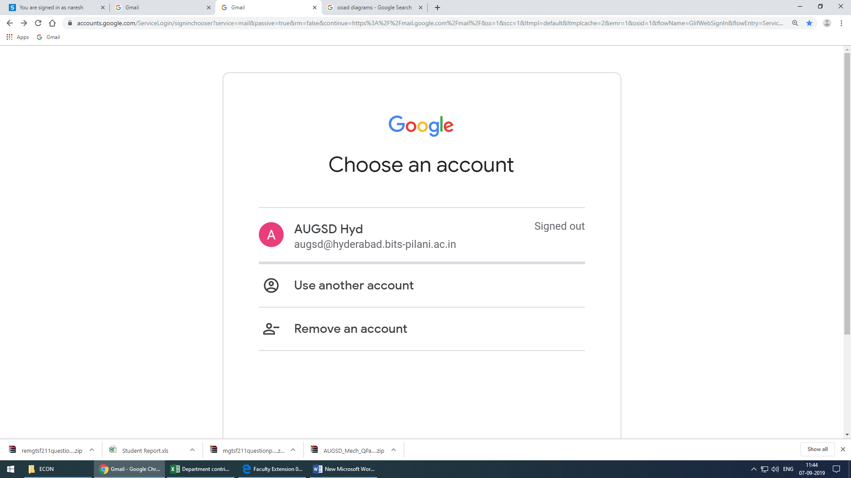

**Page Selection**

[Instructor-in-Charge](mailto:Instructor-in-Charge)

[DCA Convener](mailto:DCA%20Convener)

**IC Page**

**Course No. Course Name Handout DCA Approval AUGSD Approval**

CS F111 Computer Prog. ✔or✘ ✔or✘

CS F213 Object Oriented Prog.

Upload (enable/disable)

Upload (enable/disable)

Submit

**DCA Convener Page**

**Course No. Course Name Handout DCA Approval AUGSD Approval**

CS F111 Computer Prog. Choose an item. (Yes/No) ✔or✘

CS F213 Object Oriented Prog. Choose an item. (Yes/No)

Download (enable/disable)

Download (enable/disable)

Submit

**AUGSD Page**

**Department**

[Biological Sciences](mailto:Biological%20Sciences)

[Civil Engineering](mailto:Civil%20Engineering)

----------

----------

[Physics](mailto:Physics)

[AUGSD](mailto:AUGSD)

[Biological Sciences](mailto:Biological%20Sciences) [Department](mailto:Department)

[Not Approved](mailto:Approved)

**Course No. Course Name Handout DCA Approval AUGSD Approval**

CS F111 Computer Prog. ✔or✘ Choose an item. (Yes/No)

CS F213 Object Oriented Prog.  Choose an item. (Yes/No)

[Approved](mailto:Not%20Approved)

**Course No. Course Name Handout**

CS F111 Computer Prog.

CS F213 Object Oriented Prog.

Download

Download (enable/disable)

Download (enable/disable)

Submit

Download

Download All Handouts